ARCS Knowledge Base

THE ARCS MODEL APPROACH THEORY

MOTIVATION is central to learning. What do we do in education and learning with the old adage “You can lead a horse to water, but you can’t make them drink”? Educators of all subjects and levels have felt the earnest desire to help students truly understand the knowledge or the skills they are about to impart and have some students simply not take an interest. While it is probable that educators will never be 100% effective in getting every student to learn, after all, the learner has to choose to learn, there are several things an educator can do to motivate the students to engage in learning.

John M. Keller, in his landmark book “Motivational Design for Learning and Performance: The ARCS Model Approach” outlined a performance model that postulated that motivation is primary to the process of learning. Keller (2010) outlined that motivation needs to be considered and designed into the learning process. This model is referred to as the ARCS model. ARCS is an acronym for:

Attention
Relevance
Confidence
Satisfaction

The model begins by outlining questions that need to be answered by the learning specialists in the motivational design process. These questions are outlined in the chart below.

Major Categories | Definitions | Process Questions
Attention | Capturing the interest of learners; stimulating the curiosity to learn | How can I make this learning experience stimulating and interesting?
Relevance | Meeting the personal needs/goals of the learner to effect a positive attitude. | In what ways will this learning experience be valuable for my students?
Confidence | Helping the learners believe/feel that they will succeed and control their success. | How can I via instruction help the students succeed and allow them to control their success?
Satisfaction | Reinforcing accomplishment with rewards (internal and external) | What can I do to help the students feel good about their experience and desire to continue learning?
Keller (2010) p. 45

Motivational Design is applied as an integral part of the Instructional Design and has designated points of entry within the Instructional Design process. The following chart outlines the integration with the ADDIE model and the ARCS Motivation model.

Phase | Instructional Design Steps | Motivational Design Steps
Analyze | - Pre-project analysis  - Conduct task, job, or content analysis  - Conduct Instructional Analysis  - Identify audience entry behaviors  - Write Performance objectives and criterion measures | - Conduct audience motivational analysis  - Write motivational objectives and criterion measures
Design | - Design instructional sequences  - Instructional methods | - Generate motivational strategies  - Select strategies  - Integrate motivational and instructional strategies
Develop | - Helping the learners believe/feel that they will succeed and control their success  - Developmental test for learning and performance (“one-on-one” tryouts) | - Select or create Instructional materials  - Prepare motivational materials  - Enhance instructional materials  - Develop test for motivation
Implement & Evaluate | - Implement with target population representatives  - Conduct formative evaluation  - Certify or revise
Keller (2010) p. 66

Recognizing the need for action and application, Keller outlined best practice strategies for each of the ARCS areas.

Attention:
Keller writes that there are three general areas that influence attention in humans. The idea is to catch and maintain the attention of the students toward the goals and objectives of the learning experience. He indicates that curiosity is a major motivator in students and that a portion of the strategy is to introduce ideas and concepts that activate interest in the subject. Students need to “wonder.” Another construct that can work against attention is boredom. Subjects and concepts that are too easy or entirely too difficult for the level of the student increase the likelihood of boredom that diminishes the motivation to learn. A third factor in instructional attention is sensation seeking. This is rather the antithesis of boredom. Learners, or all humans, are actively seeking the next sensation. It is this sensation seeking that often spurs curiosity in the activities of learners.

Strategies for obtaining and maintaining attention and curiosity fall along the creative practices of capturing interest (sensation and curiosity); stimulating inquiry (again tied to curiosity); and maintaining attention. Maintaining attention involves strategies of variation in delivery and content. As we notice television and film strategies, we can see that they changes are happening quickly with plenty of variation. This helps keep the audience’s attention. Instructors would do well to follow such a model.

Relevance:
Much of the goal of relevance is the challenge making plain to the student how the learning pertains to them. Much of the orientation in relevance is in tying the learning to the student’s personal goals and values. We must define how concepts, ideas and activities should be of interest to the students. Some strategies that pertain to establishing relevance are clearly relating the instruction to the goals of the student; matching the student’s interests; and tying current learning to the students past personal experience.

Confidence:
“Confidence refers generally to people’s expectancies for success.” (Keller 2010, p. 135) The whole “Confidence” stage is about helping the student realize that they can and are a success. It is the process of outlining instruction that allow students the opportunity to control their success. It is putting the learning within their control. Bandura (1977) refers to this confidence as self-efficacy. Students need to believe they can succeed. Keller outlines three constructs for the development of confidence. These strategies are 1) establishing clear learning requirements; 2) providing opportunities for success; and 3) helping students accept and benefit from personal responsibility. They need to know that success is within their control. The following chart outlines these three strategies with supporting questions and tactics.

Concepts & Process Questions | Main Supporting Tasks
Learning Requirements  How can I assist in building a positive expectation for success? | Establish trust and positive expectations by explaining the requirements for success and the evaluative criteria.
Success Opportunities  How will the learning experience support or enhance the learner’s beliefs in their competence? | Increase belief in competence by providing many, varied, and challenging experiences that increase learning success.
Personal Control  How will the learners clearly know their success is based upon their efforts and abilities? | Use techniques that offer personal control (whenever possible), and provide feedback that attributes success to personal effort.
Keller (2010) p. 159

Satisfaction:
The key question in motivating in the satisfaction domain is “What can I do to help the students feel good about their experience and desire to continue learning?” Much of the thought relative to establishing satisfact has its roots in behavioristic concepts of classical and operant conditioning. On the extrinsic motivation side, satisfaction is allowed to grow through concepts of positive reinforcement. In this case the learning becomes pleasurable, therefore satisfying. Below is a table outlining concepts and supporting strategies for satisfaction.

Concept & Process Questions | Main Supporting Strategies
Intrinsic Reinforcement  How can I encourage and support their intrinsic enjoyment of the learning experience? | Provide feedback and other information that reinforces positive feelings for personal effort and accomplishment.
Extrinsic Rewards  What will provide rewarding consequences to the learners’ successes? | Use verbal praise, real or symbolic rewards, and incentives, or let learners present the results of their efforts (“show and tell”) to reward success.
Equity  What can I do to build learner perceptions of fair treatment? | Make performance requirements consistent with stated expectations, and use consistent measurement standards for all learners’ tasks and accomplishments.

Bandura, A. (1977). Self-efficacy: Toward a unifying theory of behavioral change. Psychological Review, 84, 191-215.

Keller, J. M. (2010). Motivational design for learning and performance: The ARCS model approach. New York: Springer.

BACKGROUND ON DEVELOPMENT OF ARCS

John M. Keller has a background in educational psychology. He was a high school teacher in California while he studied psychology at San Diego State University. He then went on to earn his Ph.D. in Instructional Systems Technology from Indiana University in 1974. While working on his doctorate, he became interested in locus of control and learned helplessness and this prompted him to investigate how these relate to instructional systems design. Though his interest in motivation and performance began during his undergraduate studies. (Simsek, 2014)
In 1979, while working as an assistant professor at Syracuse University, Keller worked with a group of graduate students to explore and analyze major motivational theories and their relationship with learning design. During this analysis, they organized the many micro-theories into a smaller number of macro-theories. Prior to his research, the motivation related theories in the instructional design field focused around many micro-theories and strategies for creating “motivational conditions”. (Simsek, 2014, p. 91) Keller came to the conclusion that with so many concepts, and a lack of direction on how to integrate them into an instructional design process, they could not be applied in a meaningful way (Simsek, 2014). There were no models that addressed instructional processes to motivate learning. The majority of the processes focused on job satisfaction and work performance, or on how to change the motivation of an individual psychologically. Educational motivation lacked a clear directional model that could be adapted to fit a particular audience. Applications-based research were restrictive and didn’t provide guidance for implementation. (Keller, 1987, p. 2) To fill this needs, the ARCS theory and learning model were created.
The two questions Keller and his students explored that led to the creation of the ARCS model were:
1) “…is it possible to synthesize the many concepts and theories of human motivation into a simple, meaningful model, or schema, that would be useful to a practitioner?” (Keller, 1987, p. 2) and
2) “…is it possible to develop a systematic, as opposed to intuitive, approach to designing motivating instruction?” (Keller, 1987, p. 2).
Keller constructed the ARCS theory and model based on his macro theory of motivation and instructional design. That theory was influenced by the works of E.C. Tolman and K. Lewin on expectancy-value theory. This theory postulates that perceived satisfaction and expectancy for success are factors that motivate engagement. (Keller, 1987, pp. 2–3) In 2008, Keller updated his model to ARCS-V to include the aspect of volition. This category provides tools for helping learners reach their goals and addresses factors that may take them off track. (Simsek, 2014, p. 93)

References:
Keller, J. M. (1987). Development and use of the ARCS model of instructional design. Journal of Instructional Development, 10(3), 2–10.

Simsek, A. (2014). Interview with John M. Keller on Motivational Design of Instruction. Contemporary Educational Technology, 5(1), 90–95.

ROLE OF ARCS MODEL OF MOTIVATION IN EDUCATIONAL PRACTICE
Keller’s ARCS Model of Motivation is very specific in how to achieve attention, relevance, confidence, and satisfaction (ARCS). Even though Keller’s theory dates back to 1970 (Weibell, 2011), its concepts are still being applied to educational settings today through research and actual practice.
Researchers like Milman and Wessmiller (2016), Zhang (2015), Proske, Roscoe, and McNamara (2014) are still using the ARCS model of motivation to explore how to achieve attention, relevance, confidence and satisfaction in online learning (p. 67), how to enhance listening proficiency in English teaching (p. 1), and to determine whether games (vs other instructional methods) can instill motivation according to the ARCS model (p. 481).
Not only is the model still being used by researchers in the educational setting, but the ARCS model is also very specific in how it can be used in educational practice because it is a tool to increase attention, connect learners with the relevance of the subject, instill confidence, and achieve satisfaction. The suggestions of how to accomplish ARCS can help educators identify specific strategies and techniques.
This model has strategies and techniques within the four main categories of attention, relevance, confidence, and satisfaction (ARCS). Below is a section for each category and its strategies and techniques, which instructors can use.

Attention
In other models attention is simply one of the first steps in the process of learning. In Keller’s ARCS model of motivation, attention needs to be catered to throughout the entire process (Milman & Wessmiller, 2016, p. 3).
Attention is split into three subsets according to Milman & Wessmiller (2016, p. 3):
- Perceptual arousal
- Inquiry arousal
- Variability
To grab attention, instructors can use the following techniques:
- Active participation – hands on ways learners can get involved in the material
- Variability – Using a variety of media and instructional methods
- Humor
- Incongruity and conflict – challenging learner’s prior knowledge
- Specific examples – through visuals or stories
- Inquiry – giving the learner an opportunity to construct hypotheses and solve it
(Learning Theories)

Relevance
Relevance refers to the idea that learners don’t want to go through instruction that won’t be useful to them (especially adult learners) (Milman & Wessmiller, 2016, p. 3).
To establish relevance, Keller identifies these six strategies:
- Experience – pull on the learner’s prior knowledge to show how it will be built upon
- Present worth – Show the learner how learning this material will help them right now
- Future usefulness – How will this material help the learner in the future?
- Modeling – Show the learners an example of success
- Choice – Let the learner select how they learn
(Pappas, 2015)

Confidence
Learners need to feel like they can be successful in order to maintain motivation. These techniques can help instill confidence.
- Objectives and prior experience needed – this helps learners evaluate whether they will be successful in the class or not
- Show progress – showing progress in the right direction can help learners begin to feel self growth
- Provide feedback
- Give the learner control – If learners feel they are in control of their learning, it can promote a sense of responsibility for their own learning
(Pappas, 2015) (Learning Theories)

Satisfaction
Satisfaction is split into intrinsic and extrinsic motivation. Intrinsic motivation can be hard to obtain but extrinsic motivation can be more easily catered to by the instructor, which can help promote satisfaction (Milman & Wessmiller, 2016, p. 4).
- Apply knowledge – If learners can apply their knowledge in real situations, this will reinforce the importance of it.
- Providing praise or reward
- Provide feedback
(Pappas, 2015) (Learning Theories)

Example
Keller’s ARCS model is a framework instructors can easily use to help identify ways to promote attention, relevance, confidence and satisfaction. Milman and Wessmiller identified very specific ways to implement the ARCS model in online learning (2016, p. 2). Their table is shown below:
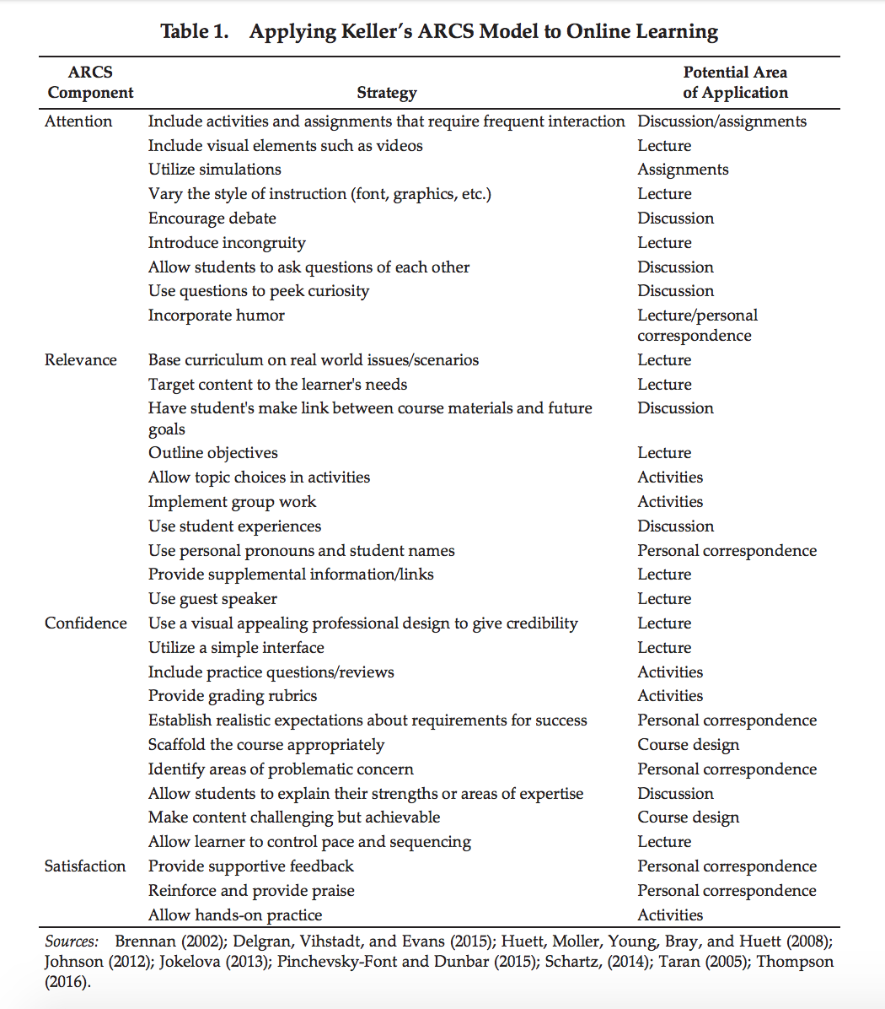

References
Learning Theories. (n.d.) ARCS MODEL OF MOTIVATIONAL DESIGN THEORIES (KELLER).Retrieved from https://www.learning-theories.com/kellers-arcs-model-of-motivational-design.html (Links to an external site.)
Milman, N. n., & Wessmiller, J. j. (2016). Motivating the Online Learner Using Keller's ARCS Model. Distance Learning, 13(2), 67-71.
Pappas, Christopher. (May 20, 2015). The Quintessential Of The ARCS Model Of Motivation. Retrieved from https://elearningindustry.com/arcs-model-of-motivation (Links to an external site.)
Proske, A., Roscoe, R., & McNamara, D. (2014). Game-based practice versus traditional practice in computer-based writing strategy training: effects on motivation and achievement. Educational Technology Research & Development, 62(5), 481-505.
Weibell, C. J. (2011). Principles of learning: 7 principles to guide personalized, student-centered learning in the technology-enhanced, blended learning environment. Retrieved fromhttps://principlesoflearning.wordpress.com (Links to an external site.)
Zhang, J. (2015). Improving English Listening Proficiency: The Application of ARCS Learning-Motivational Model. English Language Teaching, 8(10), 1-6.

