An Introduction to Scales and Key Signatures in Music

This course is a basic music theory learning experience that introduces the fundamental elements of pitch, intervals, clefs, scales and key signatures. It is designed for students with no prior music experience. A placement pre-test will place students at the level of prior understanding if they come to the course with some prior experience. The delivery is interactive computer assisted instruction with lessons and lots of practice to master the concepts. It is estimated that it will take students about 3 hours to complete the course from the beginning to the end. Below is a glossary of the fundamental vocabulary for the course and this report.

Glossary:
Aural: Examples that are given for listening.
Baseline Note: The first note for comparison.
Flat: (b) Also known as bemolle, it means to lower the pitch one-half step.
Half-step The smallest and most fundamental interval. Twelve half-steps create an octave.
Interval: The space between two pitches or notes.
Key Signature: Contains flats or sharps and defines the scale being used in the music.
Leading Tone: The seventh note of the scale, one half-step below the tonic or root note.
Major Scale: Eight successive notes with the first and last being an octave apart with the interval map of WWHWWWH steps (W = Whole, H = Half).
Note: Visual representation on a music staff of a pitch.
Octave: A pitch at twice the frequency above a baseline note is an octave.
Pitch: A sound at any given frequency. Pitch is usually aural whereas notes are visual.
Root note: The tonic, base-note, or identifying note of a scale. The first note.
Sharp: (#) Raise the pitch one-half step.
Tonic: The root or base note of a scale.
Treble Clef: Often called the G Clef, the treble clef indicates notes generally above middle C on the piano.
Whole-step Two half-steps. The major scale is made of 5 whole-steps and 2 half-steps.

- Activity Report
Craig Ferrin: Created the Design Evaluation Chart, Lesson Plan Development Charts and PowerPoint Slides as examples of learning and assessment frames. Outlined the plan on paper following the model given in the class instructions. Investment of about 20 hours. Chris and Georgina were wonderful in their help on the format and editing. I could not have done it without them.

Georgina Valls-Mayor: Craig Ferrin was so engaged in the design from the first day that really went all the way with it and he did a spectacular job. Since I took the role of the Evaluator, I created a Glossary of terms thinking about students without prior musical training. Craig added a few terms to the list later on. I reviewed and edited the course. Chris also provided the portion of Analysis, which was very valuable. My overall dedication was about 3 hours.

Chris McCormick: I spent about three hours going over and review the content Craig sent me. I did another 2 1/2 hours of work of following the lesson plan through to test it as a learner might to see if there were any possible part of confusion or any benefits that could be made to the content and the approach made.

- Analysis Report Commentary
The biggest comment on the Assessment Report is the Performance Context. How will learners use this learning? Mostly at home to start with. Eventually students can share with friends and family. Our learners have other careers and no plans to switch. They are learning for a hobby. The knowledge gained in the training regarding scales and key signatures is foundational to music performance and composition, professionally or recreationally.

- Learning Objectives: The Design Evaluation Chart

Skills | Conditions | Performance Objective | Assessment
Create Major Scales (Keyboard) | Students will be given a root note in an online keyboard. | Students will create a major scale up and down on the keyboard with 95% accuracy on all 12 notes in the scale. | On all of these, please see the slides in the Appendix.
Create Major Scales (Visual) | Students will be given a note on the treble clef staff. | Students will create ascending major scales based upon each of the 12 notes with 90% accuracy. | On the given note, create a major scale up and down using sharps and flats to create the appropriate whole-steps and half-steps.
Identify Key Signatures | Students will be given several examples of key signatures in treble clef. | students will identify major key signatures with 90% accuracy. | Identify the correct keynote or key of the following key signatures.
Create Key Signatures | Students will be given a treble clef staff. | Students will create all 12 major key signatures with 90% accuracy. | Match the following key signatures with the correct key name.
1.Pitch & Intervals | Students will be given several aural examples of two pitches that create an interval. | Students will identify intervals as whole-step or half-step with 90% accuracy. | Identify the following aural example as either a whole step interval or a half-step interval.
1a. Definition of music: Organized sound and silence in time. | Students will be given a fill-in-the-blank sentence of the definition of Music. | Students will fill in the blanks with the correct words with 90% accuracy. | Fill in the blank: Music is defined as organized sound and silence in time.
1b. Identify intervals: whole steps and half steps | Students will be given several aural examples of two pitches that create an interval. | Students will identify intervals as whole-step or half-step with 90% accuracy. | Identify the following aural example as either a whole step interval or a half-step interval.
2.Piano Keyboard Visualization of pitch | Students will be given a keyboard. | Students will play several examples of the requested pitch on the keyboard with 90% accuracy | Play on the electronic keyboard above the pitch F#. (or A, B, C, D, E, F, G, G#, A#, C#, D#, E#, B#, Bb, Ab, Gb, Eb, Db, Fb, or Cb) (For this paper, #=sharp, b=flat)
2a. Each key on the piano keyboard sounds certain pitch | Students will be given a keyboard | Students will play several examples of the requested pitch on the keyboard with 90% accuracy | Play on the electronic keyboard above the pitch C. (or DEFGAB)
2b. Each key is a half-step from its adjacent keys | Students will be given a keyboard with an identified note. | Students will play the pitch one half-step up or down from an identified pitch with 90% accuracy. | -Play the key one half-step up from the note identified on the keyboard.  -Play the key one half-step down from the note identified on the keyboard.
2c. Flats & Sharps | Students will be given a keyboard. | Students will play several examples of the requested pitch on the keyboard with 90% accuracy | Play on the electronic keyboard above the pitch F#. (or G#, A#, C#, D#, E#, B#, Bb, Ab, Gb, Eb, Db, Fb, or Cb) (For this paper, #=sharp, b=flat)
3.Pitch Visualization | Students will be given a series of notes on the staff. | Students will tap the pitch on the keyboard that corresponds to the given note on the staff in a series of given notes with 90% accuracy. | Play the pitch on the keyboard that corresponds to the note given above. (several examples)
3.Pitch Visualization | Students will be shown a series of identified pitches on a keyboard | Students will drag and drop a note on to the treble clef that corresponds to the given pitches on the keyboard with 90% accuracy | Drag and Drop the appropriate note to the location on the staff that corresponds to the pitch played on the keyboard.
3a. Identify and create a treble clef staff | Students will be shown a five-line staff. | Students will drag and drop a treble clef sign centered on G with 100% accuracy. | Drag the treble clef sign to its appropriate location on the staff.
3b. Identify pitches on a staff | Students will be shown a series of examples of notes on the treble clef staff. | Students will identify the given notes with 90% accuracy. | Identify the note given above.
3c. Create pitches on a staff | Students will be given a treble clef staff and a drag and drop note. | Students will drag and drop a note to the named location on the treble clef staff with 90% accuracy | Drag and drop the note to its identified position on the treble clef staff.
3d. Identifying pitches using sharps and flats. | Students will be shown a series of examples of notes on the treble clef staff with sharps and flats. | Students will identify the given notes with 90% accuracy. | Identify the note given above.
3e. Create sharp and flat pitches on a staff. | Students will be given a treble clef staff and a drag and drop note. | Students will drag and drop a note to the named location on the treble clef staff with 90% accuracy | Drag and drop the note to its identified position on the treble clef staff.
3f. Identifying and creating all notes, including sharps and flats. | Students will be given a mixed series of notes to identify, or a staff to place notes on. | Students will either identify notes or place the given note on as staff with 90% accuracy. | Identify the note given above. Drag and drop the appropriate note to its location of the staff.
3g. Identifying visual notes on the keyboard | Students will be given a series of notes on the staff. | Students will tap the pitch on the keyboard that corresponds to the given note on the staff in a series of given notes with 90% accuracy. | Play the pitch on the keyboard that corresponds to the note given above. (several examples)
3h. Creating notes on a staff from an identified pitch on the keyboard | Students will be shown a series of identified pitches on a keyboard | Students will drag and drop a note on to the treble clef that corresponds to the given pitches on the keyboard with 90% accuracy | Drag and Drop the appropriate note to the location on the staff that corresponds to the pitch played on the keyboard.
4.Major/Non-Major | Students will be given several aural examples of major and non-major scales and melodies. | Students will identify each aural example as major or non-major with 90% accuracy. | Play the above recording of a scale or melody. Identify the example as either major or non-major.
4a. The sound of a major and non-major scales | Students will be given several aural examples of major and non-major scales. | Students will identify each aural example as a major or a non-major scale with 90% accuracy | Play the above recording of a scale. Identify the scale as either major or non-major.
4b. The sound of major and non-major melodies | Students will be given several aural examples of major and non-major melodies. | Students will identify each aural example as a major or a non-major melody with 90% accuracy | Play the above recording of a melody. Identify the scale as either major or non-major.
5.The Major Scale | Having been instructed that the intervals of a major scale are WWHWWWH, students will be given a natural note on treble clef staff. | Students will construct a major scale on each given natural note using sharps and flats to create whole-step and half-step intervals to create major scales with 90% accuracy. | On the given note, create a major scale up and down using sharps and flats to create the appropriate whole-steps and half-steps.
5a. Construction of the basic major scale: keyboard (CDEFGABC)(White Keys) | Having been instructed that the intervals of a major scale are WWHWWWH, students will be given several examples of natural scales beginning on any white key. (W=Whole-Step, H=Half-step) | Students will identify the whole and half steps in each scale and identify the scales as major or non-major with 90% accuracy. | Identify the whole steps and half steps in each of the following natural scale examples. Identify the scales as major or non-major
5b. Construction of the basic major scale: keyboard | Having been instructed that the intervals of a major scale are WWHWWWH, students will be given a note on the keyboard. | Students will play a major scale on the keyboard starting on the designated keynote with 90% accuracy. | On the give keynote on the piano, perform a major scale up and down adding the necessary black keys.
5c. Construction of the basic major scale: visual | Having been instructed that the intervals of a major scale are WWHWWWH, students will be given a natural note on treble clef staff. | Students will construct a major scale on each given natural note using sharps and flats to create whole-step and half-step intervals to create major scales with 90% accuracy. | On the given note, create a major scale up and down using sharps and flats to create the appropriate whole-steps and half-steps.
6.Quickly Identifying and Creating Sharp Key Signatures | Having been instructed that the order of the sharps is FCGDAEB, and that the key of has no flats or sharps, students will be given a key name. | Students will match the shown key signatures with its correct key name with 90% accuracy. | Match the following key signatures with the correct key name.
6a. Key of C | Having been instructed that a major scale beginning C has not flats or sharps. | See immediately below. | See immediately below.
6b. Order of the sharps | Having been instructed that the last sharp in a key signature is the leading tone to the keynote, students will be shown several examples sharp and natural key signatures | Students will identify the keynote, or name of the major scale with 90% accuracy. | Identify the key note or key from the key signatures shown below.
6c. Creating a sharp key signature. | Having been instructed that the order of the sharps is FCGDAEB, and that the key of has no flats or sharps, students will be given a key name. | Students will match the shown key signatures with its correct key name with 90% accuracy. | Match the following key signatures with the correct key name.
7. Quickly Identifying and Creating Flat Key Signatures | Having been instructed that the flats appear in the order of BEADGCF, and that second to the last flat in a key signature is the key note, students will be given a series of key names. | Students will identify the correct key signature that corresponds with the given keynote with 90% accuracy. | Match the following key signatures with the correct key name.
7a. Order of the flats.  Identifying the key note from flat key signatures. | Having been instructed that the flats appear in the order of BEADGCF, and that second to the last flat in a key signature is the key note, students will be shown a series of flat key signatures. | Students will identify the keynote or key with 90% accuracy | Identify the correct keynote or key of the following key signatures.
7b. Creating flat key signatures. | Having been instructed that the flats appear in the order of BEADGCF, and that second to the last flat in a key signature is the key note, students will be given a series of key names. | Students will identify the correct key signature that corresponds with the given keynote with 90% accuracy. | Match the following key signatures with the correct key name.
8.Identifying and Creating all Major Key Signatures | Students will be shown a series of key signatures on a treble clef staff.  Students will be given a series of key names. | Students will identify the keynote or key with 90% accuracy.  Students will identify the correct key signature that corresponds with the given keynote with 90% accuracy. | Identify the correct keynote or key of the following key signatures.  Match the following key signatures with the correct key name.
8a. Identifying the keynote from any given key signature. | Students will be shown a series of key signatures on a treble clef staff. | Students will identify the keynote or key with 90% accuracy | Identify the correct keynote or key of the following key signatures.
8b. Creating the key signature from any given keynote. | Students will be given a series of key names. | Students will identify the correct key signature that corresponds with the given keynote with 90% accuracy. | Match the following key signatures with the correct key name.

- Sample Assessments
See Appendix A – Drill and Assessment Examples

- Delivery System:
Computer-based instruction in programmed manner. Each page has a concept and a short activity or assessment for learning. The learning units will be developed and delivered in Adobe Captivate or equivalent program. This program allows for the input of aural examples into the lessons. Appendix A has several examples of what the frames will look like in the programmed instruction.

- Instructional Sequence
The Instructional Sequence is evident in the Design Evaluation Chart (Item 3) and Lesson Development (Item 7).

- Pre-Instructional Activities
  - Explanation of the importance of scales and key signatures in the understanding and performance of music. All music is built upon scales.
  - Pre-Test. A pre-test will be administered as a type of placement exam in the course. While the course is designed for students with no prior music instruction, the pre-test will place the student in a unit that best fits their prior experience if any. If they already understand the concepts of pitch and intervals, and the music keyboard, the treble clef staff, and pitch notation, they can be placed where they can continue the learning experience with scales and key signatures. The entire course can be done by someone with no experience. However, if they have experience they can be placed further in the course.
  - The pre-test also serves to alert the learner what to expect in the course.

Pre-Test
Skills | Conditions | Performance Objective | Assessment
1.Pitch & Intervals | Students will be given several aural examples of two pitches that create an interval. | Students will identify intervals as whole-step or half-step with 90% accuracy. | Identify the following aural example as either a whole step interval or a half-step interval.
2.Piano Keyboard Visualization of pitch | Students will be given a keyboard. | Students will play several examples of the requested pitch on the keyboard with 100% accuracy | Play on the electronic keyboard above the pitch F#. (or A, B, C, D, E, F, G, G#, A#, C#, D#, E#, B#, Bb, Ab, Gb, Eb, Db, Fb, or Cb) (For this paper, #=sharp, b=flat)
3.Pitch Visualization | Students will be given a series of notes on the staff. | Students will tap the pitch on the keyboard that corresponds to the given note on the staff in a series of given notes with 90% accuracy. | Play the pitch on the keyboard that corresponds to the note given above. (several examples)
4.Pitch Visualization | Students will be shown a series of identified pitches on a keyboard | Students will drag and drop a note on to the treble clef that corresponds to the given pitches on the keyboard with 90% accuracy | Drag and Drop the appropriate note to the location on the staff that corresponds to the pitch played on the keyboard.
5.Major/Non-Major | Students will be given several aural examples of major and non-major scales and melodies. | Students will identify each aural example as major or non-major with 90% accuracy. | Play the above recording of a scale or melody. Identify the example as either major or non-major.
6.The Major Scale | Having been instructed that the intervals of a major scale are WWHWWWH, (W = Whole-step, H = Half-step)students will be given a natural note on treble clef staff. | Students will construct a major scale on each given natural note using sharps and flats to create whole-step and half-step intervals to create major scales with 90% accuracy. | On the given note, create a major scale up and down using sharps and flats to create the appropriate whole-steps and half-steps.
7.Identifying Key Signatures | Students will be shown a series of key signatures on a treble clef staff. | Students will identify the keynote or key with 90% accuracy | Identify the correct keynote or key of the following key signatures.
8.Creating Key Signatures | Students will be given a series of key names. | Students will identify the correct key signature that corresponds with the given keynote with 90% accuracy. | Match the following key signatures with the correct key name.

- Lesson Development

- Objective: Students will identify intervals as whole-step or half-step with 90% accuracy.
CONTENT PRESENTATION:
Content: Music is made up of pitches that are played simultaneously and/or sequentially. The space between any two pitches is called and interval. The most fundamental intervals in music are the whole-step and the half-step. Two half-steps are equivalent to a whole step. Listen to the following examples of half-steps and whole-steps.
Examples: See Appendix A: “1a Assessment” and “1 Assessment.”
Student Groupings & Media Selection: A few recordings of aural whole-steps and half-steps need to be prepared to as examples of what whole-steps and half-steps sound like.
STUDENT PARTICIPATION:
Practice Items and Activities: Practice identifying whether an interval is a whole step or a half-step. The aural examples will play the same first note for the whole-step and half-step so students can compare more easily. Eventual examples will play the melodic intervals without a baseline note. Twelve examples ought to be sufficient.
Feedback:
Student Groupings and Media Selection:
Media Selection: Recordings of melodic whole-steps and half-steps will need to be developed. Each example on one page should have buttons for “whole-step” and “half-step.”

Student Groupings: as students are working individually in a computer-assisted instruction environment, students will be working on their own.

- Objective: Students will play several examples of the requested pitch on the keyboard with 100% accuracy
CONTENT PRESENTATION:
Content: Student will be instructed in the online format using a keyboard on the page (see examples) about the names of the keys on the piano keyboard. They will have several exercises of a note being played on the keyboard with the student identifying the key being played. Students will also have several exercises of being given the name of the pitch or key and have them play the key on the keyboard. The process will begin with only identifying white keys. As expertise grows in the student, black keys (sharps and flats) will be added to the exercises.
Examples: See Appendix A: 2 Assessment
Student Groupings & Media Selection: Media will need to be developed to identify a performed key on the keyboard and correlate this with the names of the keys.
STUDENT PARTICIPATION:
Practice Items and Activities: Students will practice key recognition by identifying keys that are played on the keyboard and then playing an identified key on the keyboard.
Feedback:
Student Groupings and Media Selection:
Media will need to be developed to identify a performed key on the keyboard and correlate this with the names of the keys.

Student Groupings: as students are working individually in a computer-assisted instruction environment, students will be working on their own.

- Objective: Students will tap the pitch on the keyboard that corresponds to the given note on the staff and students will drag and drop a note to the treble clef staff that corresponds to the given pitch on the key board is a series with 90% accuracy.
CONTENT PRESENTATION:
Content:
- Students will be taught to identify and create a treble clef staff with exercises to anchor the material.
- Students will be taught the names of notes on the staff, EGBDF, Every Good Boy Does Fine for the lines, and FACE for the spaces. Students will also be introduced to ledger lines. Students will engage in exercises of identifying the note on the staff and placing the requested note on the staff.
- Students will be taught the visual use of flats and sharps with the notes and will have exercises identifying notes on a staff and placing notes on the staff.
- Students will be taught to correlate the keys on the keyboard with the notes on the staff. Students will have formative exercises of seeing a note and playing on the keyboard, seeing a given note being played on a keyboard, and then placing that note on the treble clef staff.
Examples: See Appendix A: 3 Assessment
Student Groupings & Media Selection: The exercises will need to be developed. The correlation between the keyboard and staff will need to be programmed into the course. See Appendix B for lesson development example.
STUDENT PARTICIPATION:
Practice Items and Activities: Activities will need to be prepared the teach and reinforce the above. Treble clef staff, names of notes, names of keys, correlating note names with key names, adding sharps and flats.
Feedback:
Student Groupings and Media Selection:
Media Selection: Media will need to be developed to identify a performed key on the keyboard and correlate this with the names of the keys. Exercises will need to be developed that correlated the notes with the staff and keyboard.

Student Groupings: as students are working individually in a computer-assisted instruction environment, students will be working on their own.

- Objective: Students will identify each aural example as major or non-major with 90% accuracy.
CONTENT PRESENTATION:
Content: Students will learn to hear examples of major and non-major sales and melodies and identify the examples as either major or non-major.
Examples: See Appendix A: 4 Assessment
Student Groupings & Media Selection: Media: Several aural examples of simple folk songs such as “Mary Had a Little Lamb,” “Lullaby,” Twinkle Little Star,” and “Amazing Grace” will be played and students will be asked to identify them as a major or non-major. Major and non-major scales will be introduced visually in notation and on the keyboard and students will learn to identify them as major or non-major.
STUDENT PARTICIPATION:
Practice Items and Activities: Students will be given several examples to practice identifying major and non-major.
Feedback:
Student Groupings and Media Selection:
Several aural examples of simple folk songs such as “Mary Had a Little Lamb,” “Lullaby,” Twinkle Little Star,” and “Amazing Grace” will be played and students will be asked to identify them as a major or non-major scales. Major and non-major scales will be introduced visually in notation and on the keyboard and students will learn to identify the melodies as major or non-major melodies.

Student Groupings: as students are working individually in a computer-assisted instruction environment, students will be working on their own.

- Objective: Students will construct a major scale on each given natural note using sharps and flats to create whole-step and half-step intervals to create major scales with 90% accuracy.
CONTENT PRESENTATION:
Content: Students will learn the construction of the major scale using the intervals of WWHWWWH (W=Whole-step, H=Half-step). They will also learn that a major scale can be constructed on any key on the piano or note on the staff using the pattern using sharps and flats. Students will receive several examples of major scales observing the keyboard and staff and will be given opportunities to create the major scale on the keyboard and on the staff on any given note on the staff or keyboard.
Examples: See Appendix A: 5 Assessment
Student Groupings & Media Selection: Media: Each frame will need to be programmed to correlate notes with keys on the keyboards. Each program will need to be programed to drop and drag notes to the staff and for the student to play and register the notes on the keyboard.
STUDENT PARTICIPATION:
Practice Items and Activities: Students will be given several opportunities to identify the notes in a major scale, alter flats and sharps to create major scales and create scales on the staff and keyboard. There will be immediate feedback and formative assessments.
Feedback:
Student Groupings and Media Selection: Each frame will need to be programmed to correlate notes with keys on the keyboards. Each program will need to be programed to drop and drag notes to the staff and for the student to play and register the notes on the keyboard.

Student Groupings: as students are working individually in a computer-assisted instruction environment, students will be working on their own.

- Objective: Students will match the shown sharp key signatures with its correct key name with 90% accuracy.
CONTENT PRESENTATION:
Content: Students will learn that the key of C has 0 flats or sharps and that the key of C-sharp has all seven notes sharped. Students will also learn the order of the sharps is FCGDAEB (Fat Cows Go Down and Eat Buttercups). They will also learn that the last sharp is the leading-tone, or second to the last note of the scale, just under the tonic (root note). Therefore, students can identify the root or tonic notes by looking at the last sharp in a key signature and going to the note or key a half-step above that key. They will also learn that if given a key note (root or tonic) they can identify the last sharp and then use all the sharps up to that last sharp. An example would be if we want the key signature for A major, we would know that the leading tone is G-sharp. We would then apply F#, C#, & G# (# = Sharp) to create the key of A Major.
Examples: See Appendix A: 6 Assessment
Student Groupings & Media Selection: Media will need to be prepared that allows students to drag and drop and key signature onto the staff that corresponds with the requested sharp or C key signature. Media will need to be prepared that shows students key signatures and asks them to identify the key.
STUDENT PARTICIPATION:
Practice Items and Activities: Several exercises will be given to students to practice identifying and creating sharp key signatures.
Feedback:
Student Groupings and Media Selection: Media will need to be prepared that allows students to drag and drop and key signature onto the staff that corresponds with the requested sharp or C key signature. Media will need to be prepared that shows students key signatures and asks them to identify the key.

Student Groupings: as students are working individually in a computer-assisted instruction environment, students will be working on their own.

- Objective: Students will identify the correct flat key signature that corresponds with the given keynote with 90% accuracy.
CONTENT PRESENTATION:
Content: Students will learn that the key of C has 0 flats and that the key of C-flat has all seven notes flatted. Students will also learn the order of the flats is BEADGCF (Big Elephants and Dogs Go Chase Foxes). They will also learn that the second to the last flat is the key or tonic note. Therefore, students can identify the root or tonic notes by looking at the second to the last flat in the key signature. They will also learn that if given a flat key note (root or tonic) they can find that flat in the order and include the flats up to that flat and then add the next. For example, if the key of A-flat is desired, students will include the flats Bb, Eb, and Ab, and then add the next Db (b = flat). Thus, the key of A-flat has four flats (b).
Examples: See Appendix A: 7 Assessment
Student Groupings & Media Selection: Media will need to be prepared that allows students to drag and drop and key signature onto the staff that corresponds with the requested flat or C key signature. Media will need to be prepared that shows students key signatures and asks them to identify the flat key
STUDENT PARTICIPATION:
Practice Items and Activities: Several exercises will be given to students to practice identifying and creating sharp key signatures
Feedback:
Student Groupings and Media Selection: Media will need to be prepared that allows students to drag and drop and key signature onto the staff that corresponds with the requested flat or C key signature. Media will need to be prepared that shows students key signatures and asks them to identify the flat key.

Student Groupings: as students are working individually in a computer-assisted instruction environment, students will be working on their own.

8. Objective:
-Students will identify the keynote or key with 90% accuracy.
-Students will identify the correct key signature that corresponds with the given keynote with 90% accuracy.
CONTENT PRESENTATION:
Content: Students will be given several exercises identifying a mix of natural, flat and sharp key signatures and to create correct key signatures by dragging and dropping examples to a staff.
Examples: See Appendix A: 8 Assessment
Student Groupings & Media Selection: This area will be to show mastery of the subject and can serve as the final assessment. Examples and questions for assessment will be drawn from prior objectives.
STUDENT PARTICIPATION:
Practice Items and Activities: Students will practice and be assessed on their ability to identify major key signatures, create major key signatures, and play major scales on the keyboard
Feedback:
Student Groupings & Media Selection: This area will be to show mastery of the subject and can serve as the final assessment. Examples and questions for assessment will be drawn from prior objectives.

Student Groupings: as students are working individually in a computer-assisted instruction environment, students will be working on their own.

- Practice/Feedback
Appendix A shows assessments for each level of the program. These assessments are also templates for practice exercises within each area of the course. Following each frame in the exercises students will be given immediate feedback with an explanation and further instruction if they do not show mastery. Practice assessments can be timed with students earning a bronze, silver or gold badge depending upon how quickly they complete with accuracy all questions in a set. Students will be instructed that smaller and frequent study is more effective than doing the course in one long sitting. Thirty minutes a day will be optimal.

- Lesson Wrap Up
The recap will emphasize that they have learned how to identify and create major scales and the key signatures that go with them. The recap will help them see that scales are in all music performed and composed and that key signatures are the indicators of those scales. To perform and compose music today, one must understand and perform scales and key signatures.

The course will train the beginner in feeling comfortable with the first steps to gradually develop a skill to play the piano. Constancy in practice will bring the certainty that each student desires when he/she first starts to learn. With the knowledge provided in this course, the student will feel confident and empowered to perform simple compositions of music.

- Pre-Test/Post-Test
The Pre-Test is included in the pre-instructional activities as a placement test prior to instruction.

Post-Test
The post-test is completion of the final items. Each concept in the course builds upon the others. By doing the final three assessments in the Design Evaluation Chart they will show their mastery of all concepts.

Skills | Conditions | Performance Objective | Assessment
The Major Scale | Students will be given a natural note on treble clef staff. | Students will construct a major scale on each given natural note using sharps and flats to create whole-step and half-step intervals to create major scales with 90% accuracy. | On the given note, create a major scale up and down using sharps and flats to create the appropriate whole-steps and half-steps.
Identifying Key Signatures | Students will be shown a series of key signatures on a treble clef staff. | Students will identify the keynote or key with 90% accuracy | Identify the correct keynote or key of the following key signatures.
Creating Key Signatures | Students will be given a series of key names. | Students will identify the correct key signature that corresponds with the given keynote with 90% accuracy. | Match the following key signatures with the correct key name.

- Reflections
Craig: Wow! What a fun assignment. This is entirely why I wanted to join the program. I wanted a set of guidelines with examples and directions about how to create a learning experience in a pseudo-systematic way. I know from prior experience that in all projects or goals we should “begin with the end in mind,” but using the assessments to guide the development of the rest of the project was a major revelation. This is the easiest I have every had a complex lesson plan fall together. I look forward to taking development courses so as create the items outlined in the design and development notes and examples. Thank you for the opportunity. It is also a great experience to work with two other scholars (Georgina and Chris) that kept my feet on the ground in a linear fashion. Great assignment.

Georgina: What can I say? Working with Craig and Chris is a pleasure. They have done their part using all the resources available and
Put their best effort in the assignments. Both the Analysis report and the Design and Development portion have been a lot of work for Craig and Chris. I have collaborated in whatever was possible at this level. So, now it is my turn, and they have put the bar really high for me to follow their steps. As the Evaluator, mine is the next step, as well as to continue working with the production of the course. The reading assignments and other theoretical aspects have also been very useful. Looking at what it has been produced so far, I am motivated to learn to play the keyboard. I am very interested in designing courses and this assignment is definitely are great reference for future work.

Chris: This was a new experience for me as I’ve worked in the field a while but haven’t had the chance design a course this way. Each company has their own take on the process and depending on where I have fallen into the organization affected how much I got to do with design step. It was very interesting to work and be more involved with the analysis and then design. Often, I’ve only been involved with the development and production of a course. I learned a lot just from interacting with Craig and Georgina. Definitely a great experience.

Appendix A
Drill and Assessment Examples
These assessment and drill items correspond with the numbers in the Design Evaluation Chart, Lesson Development, and Pre-Test and Post-Test Items. The examples are not comprehensive. Many more slides will need to be made to develop the lessons, provide appropriate drill and assess the learner’s mastery. These items are merely examples or even templates for future use. In these examples, the piano keyboard has the keys labeled. They will be labeled in the early portions of the course but the labels will be removed when they should become unnecessary for the students. In final product audio examples will be embedded in the slides. The course will be delivered through computer-assisted programmed instruction over the internet, developed and delivered through Adobe Captivate, Camtasia, or other, similar program.

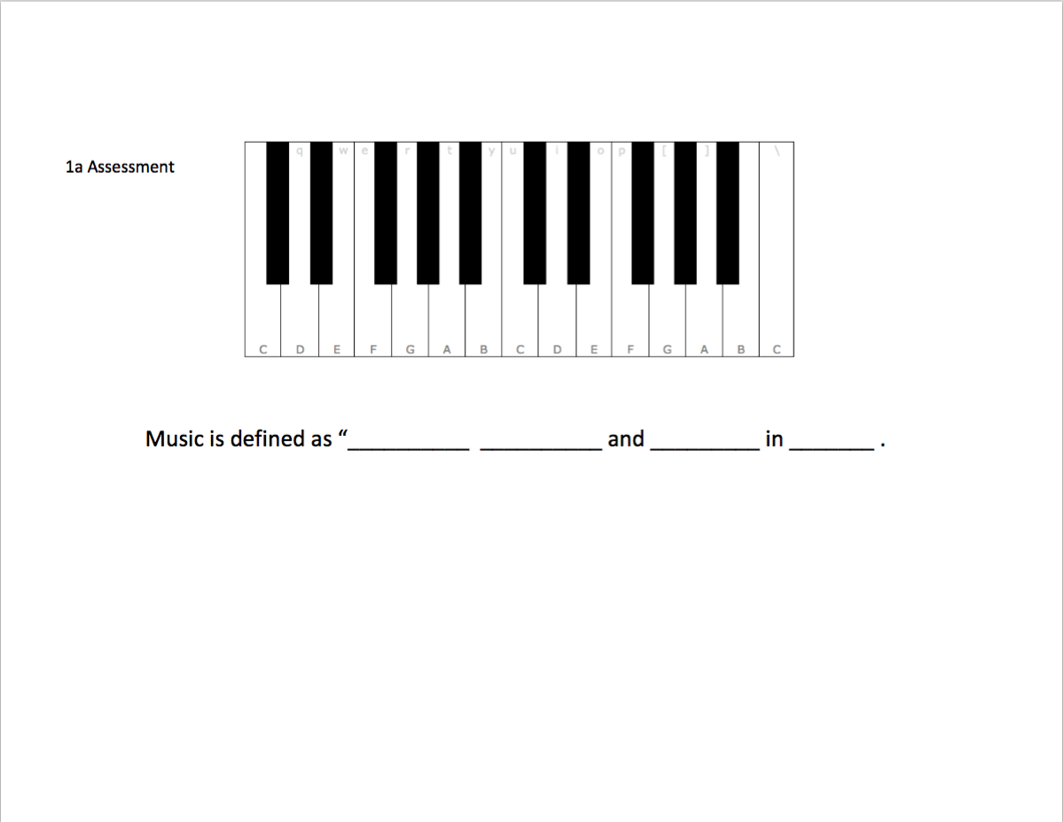
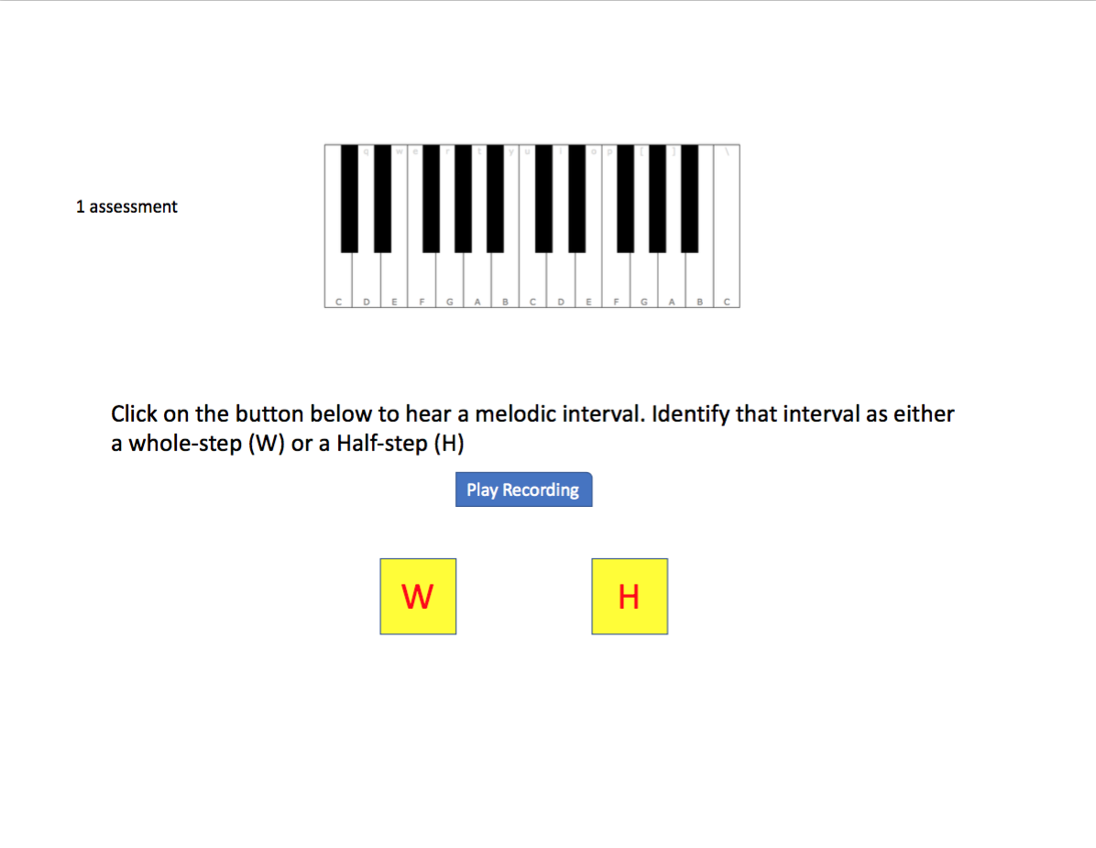
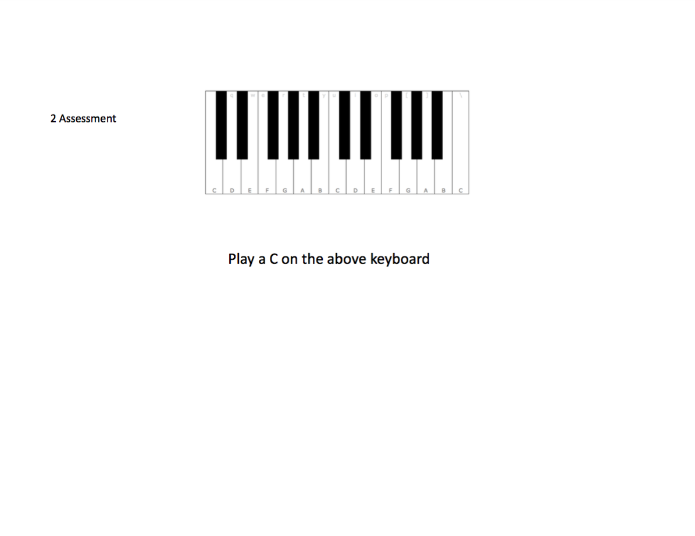
The note names will be removed from the keyboard for these exercises and assessments.
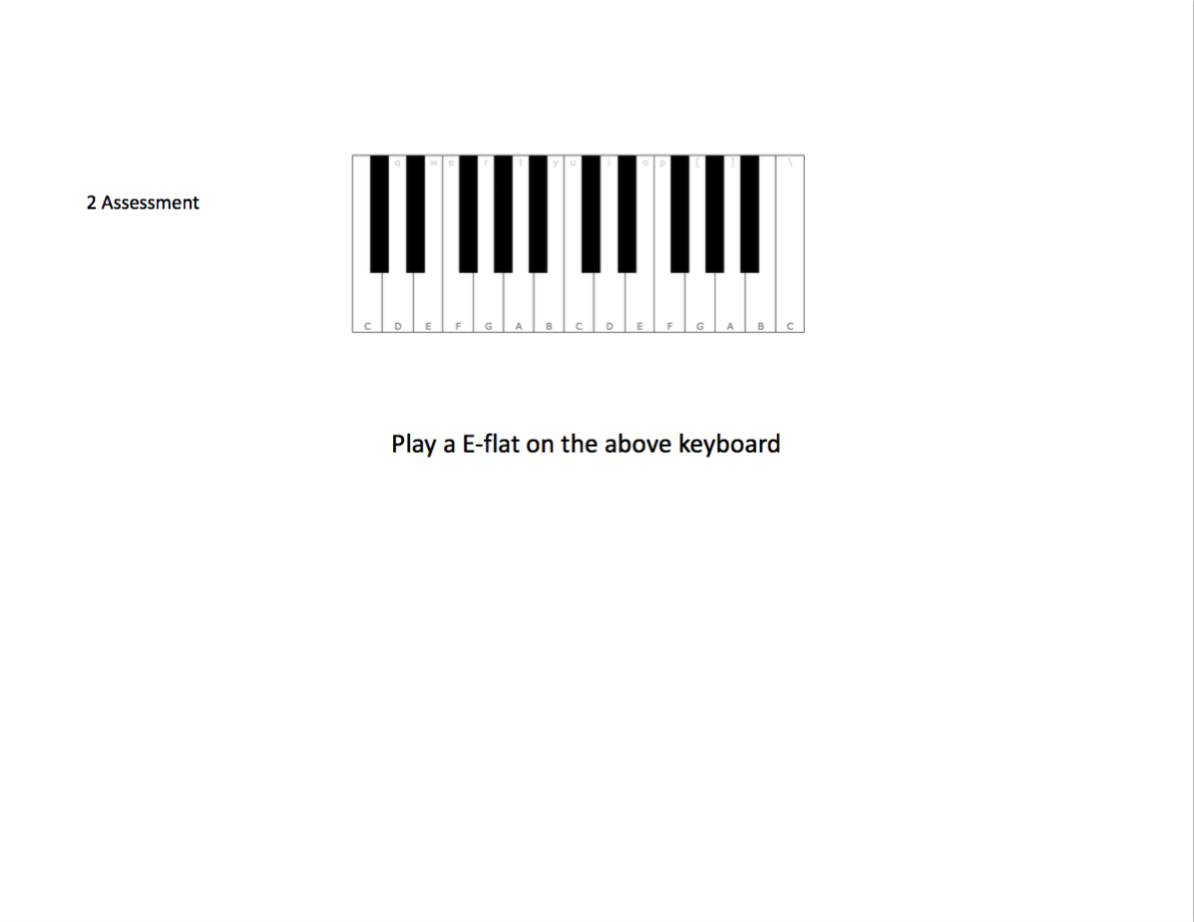
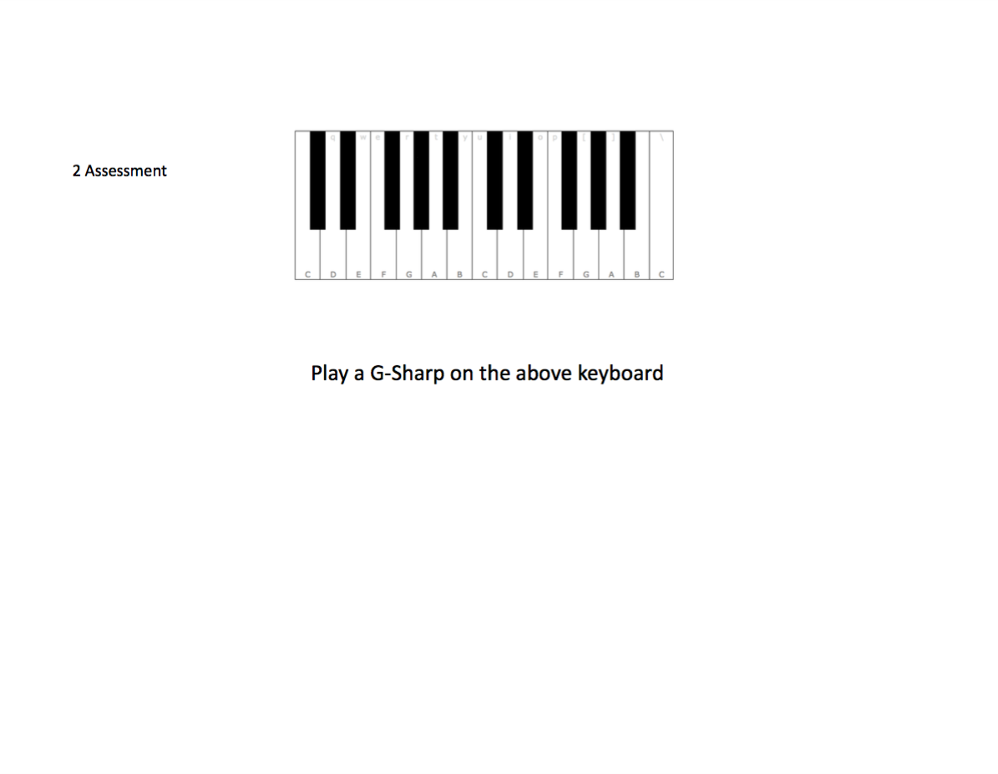
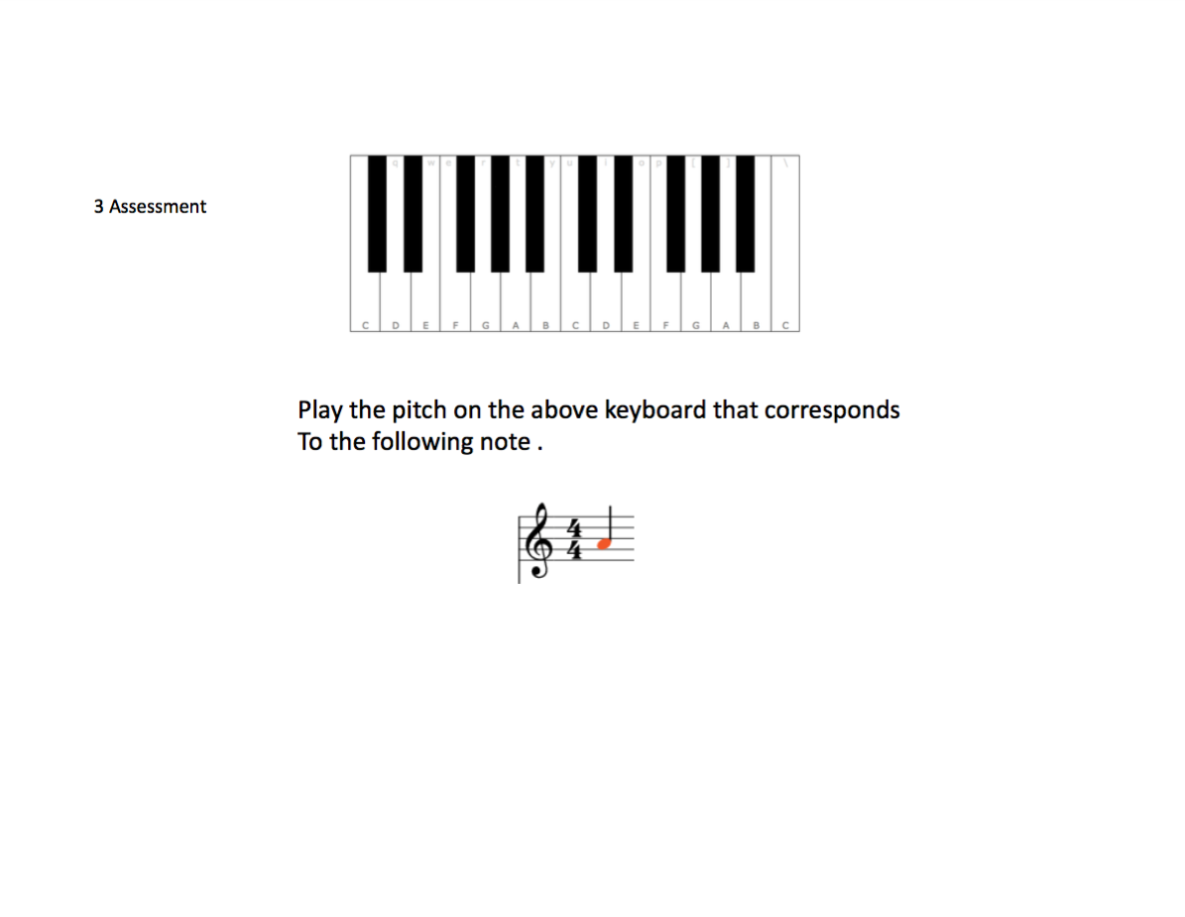
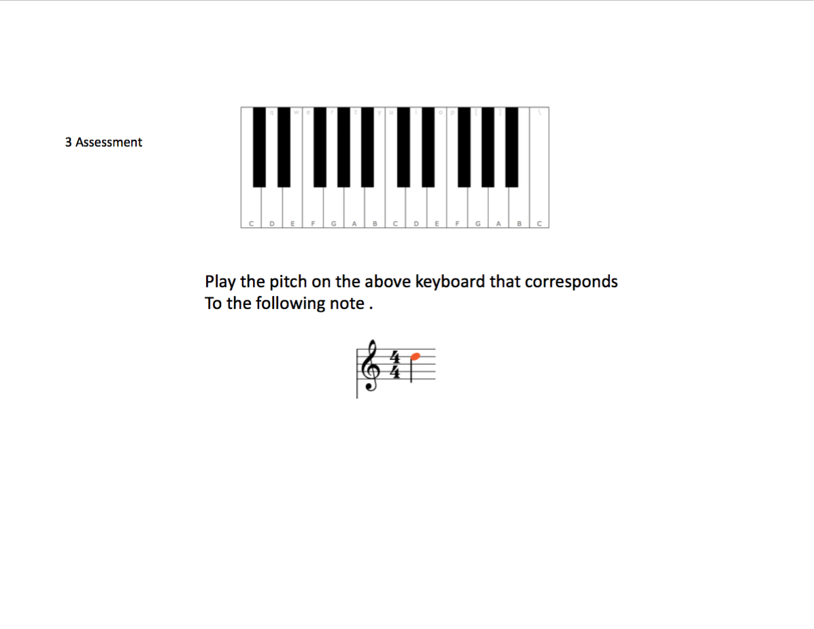
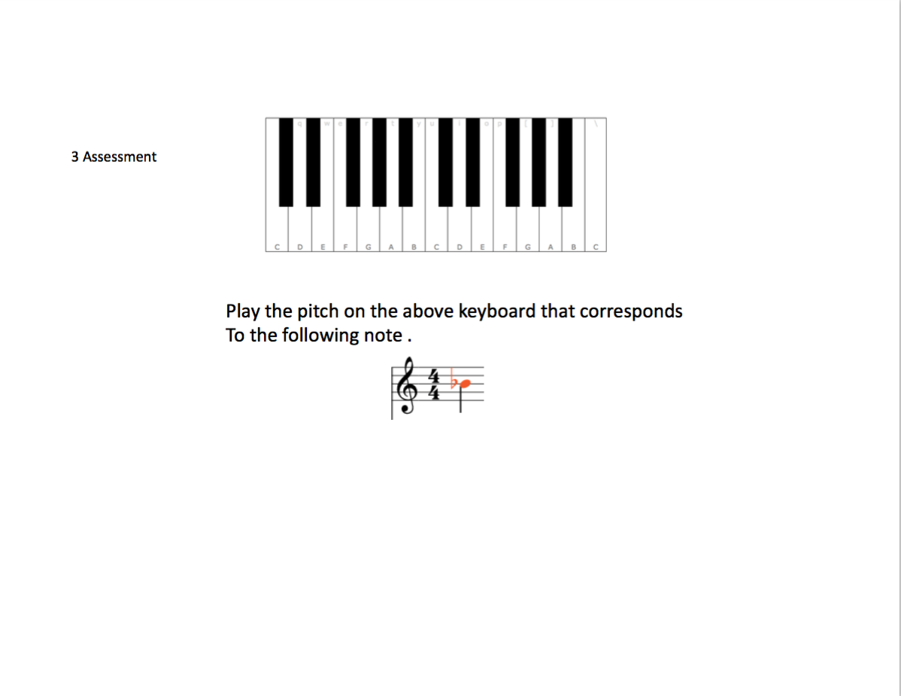
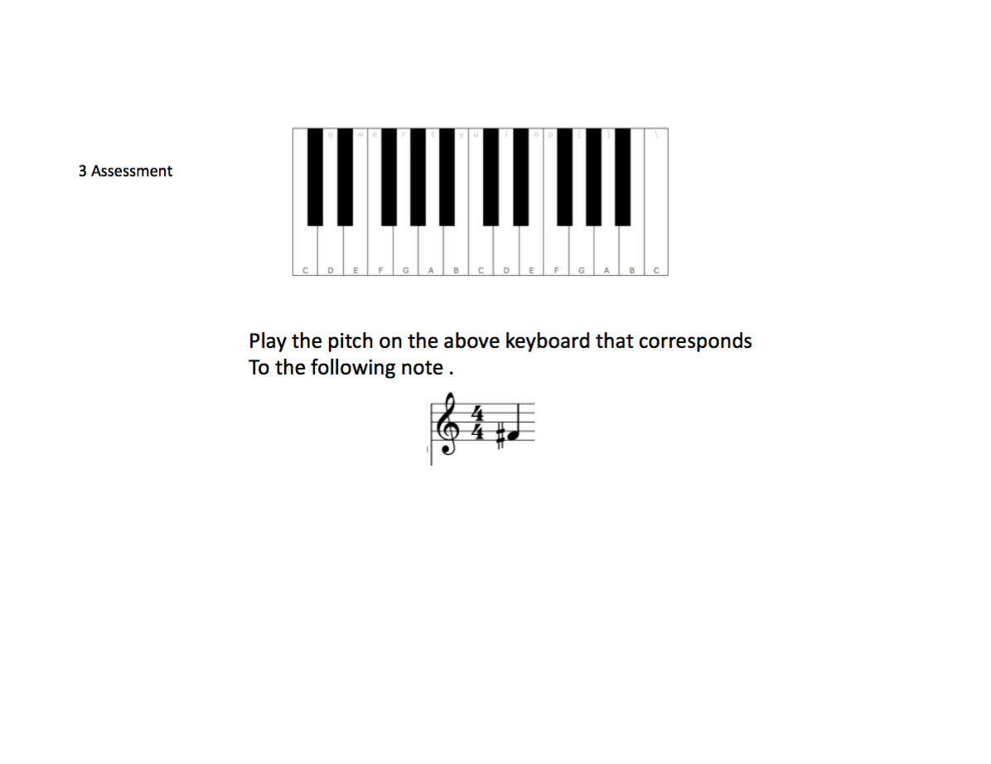
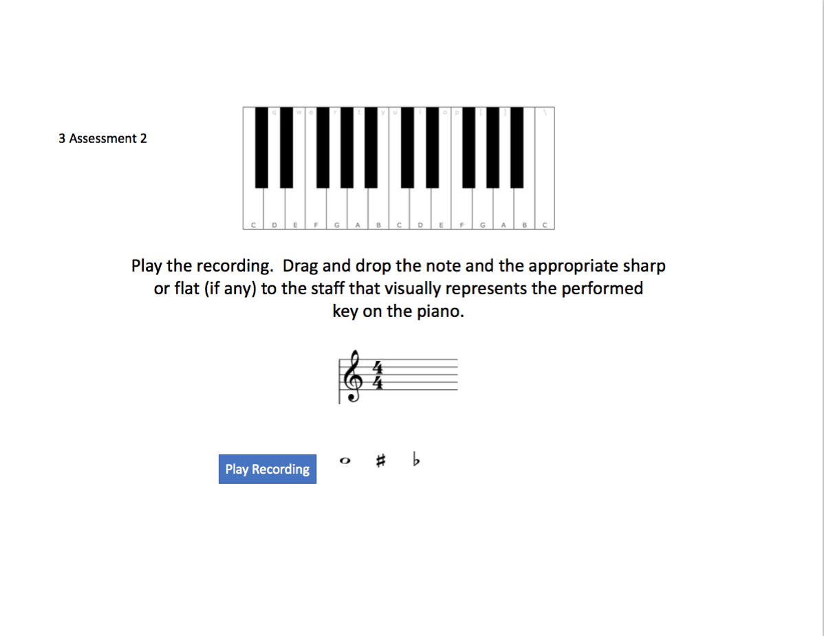
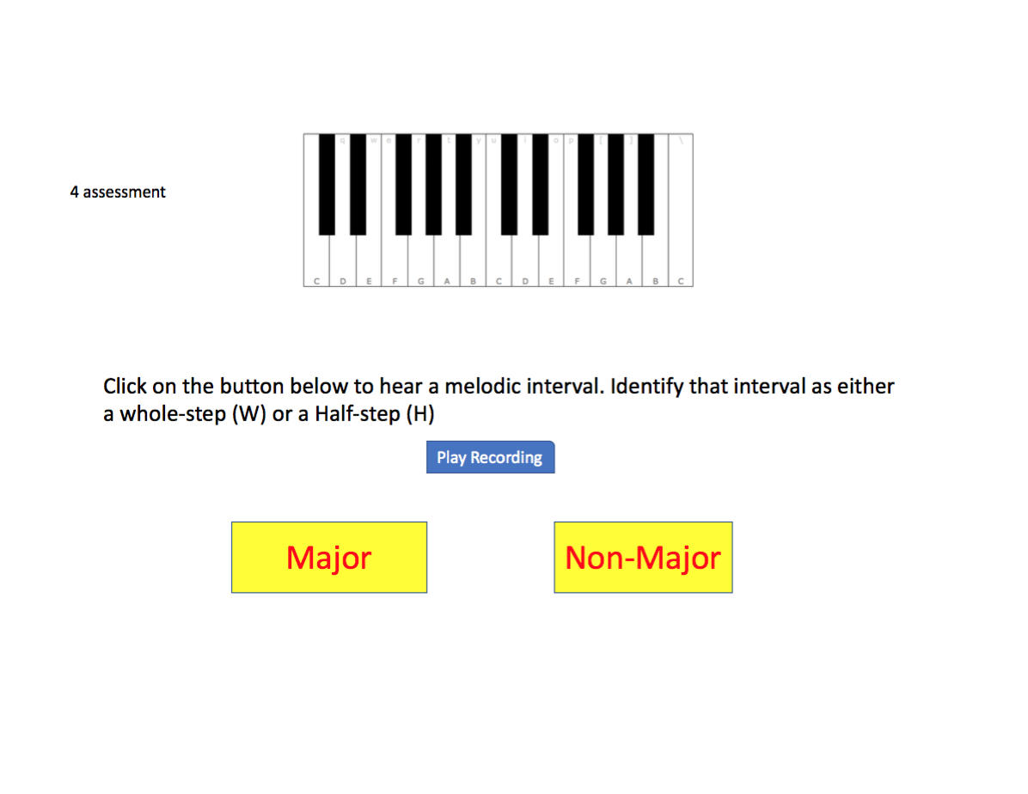
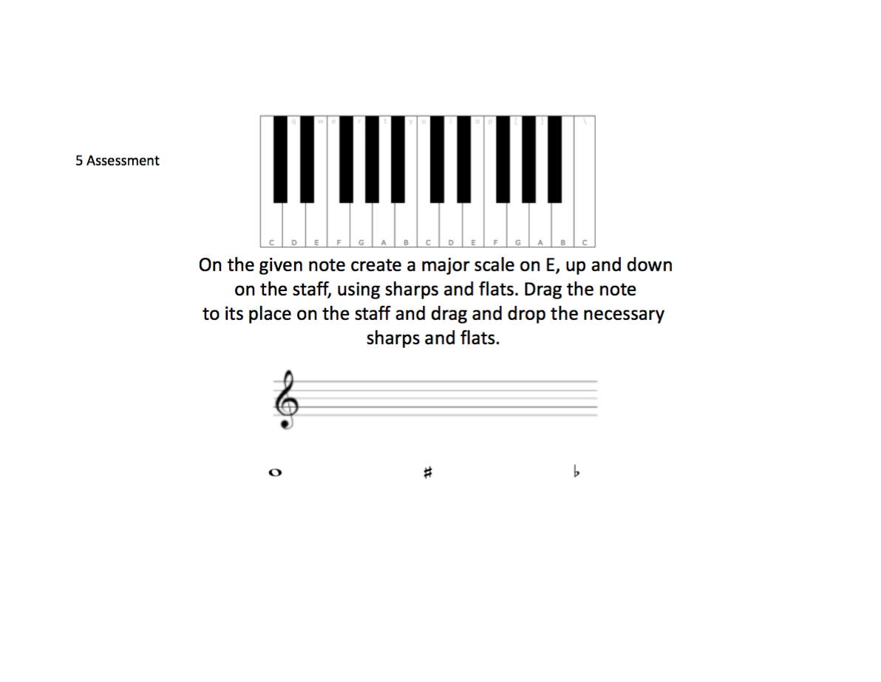
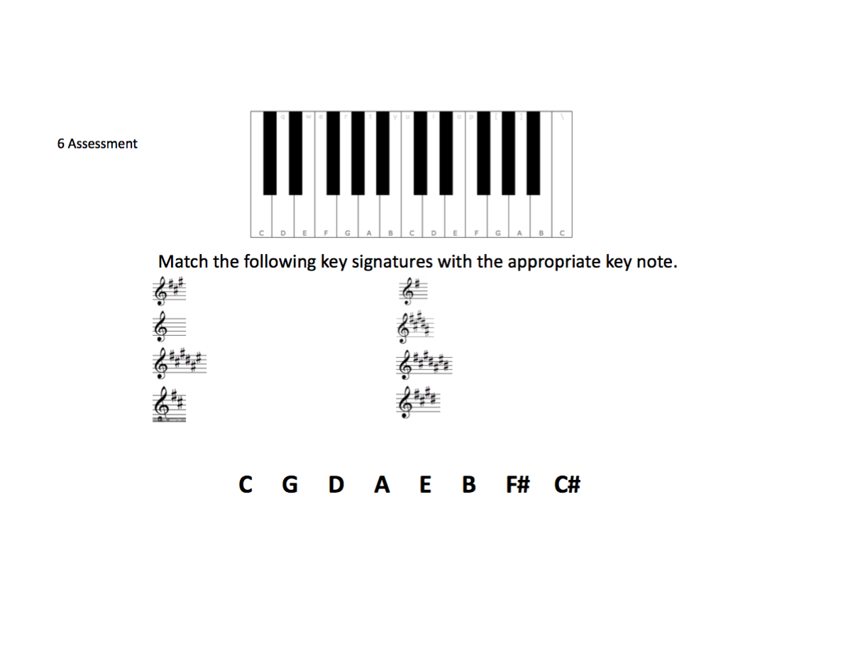
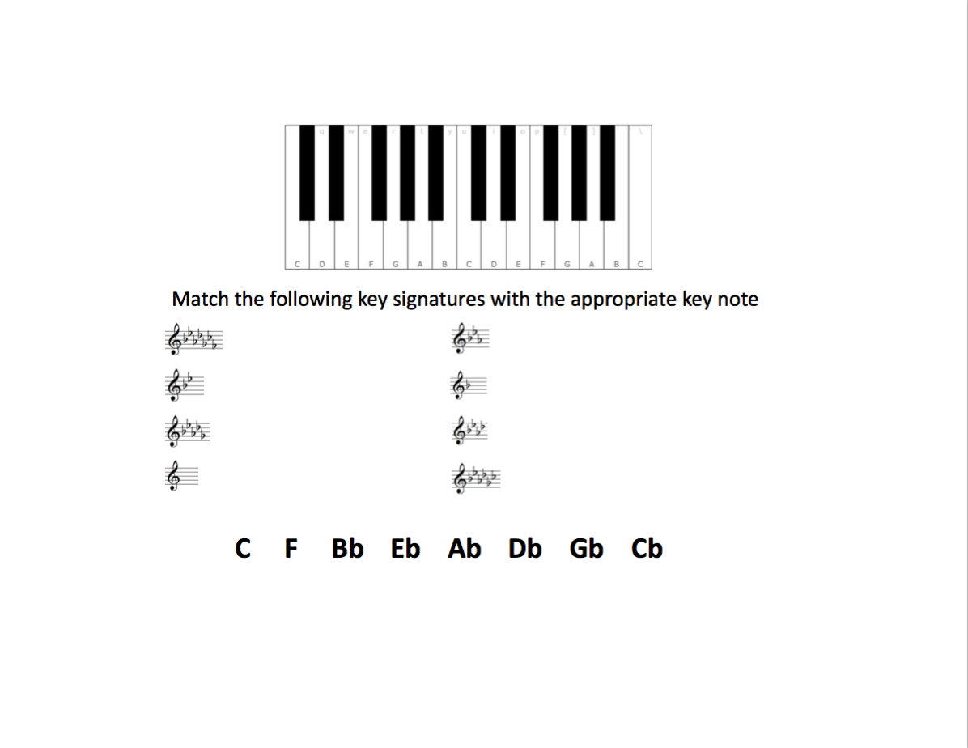
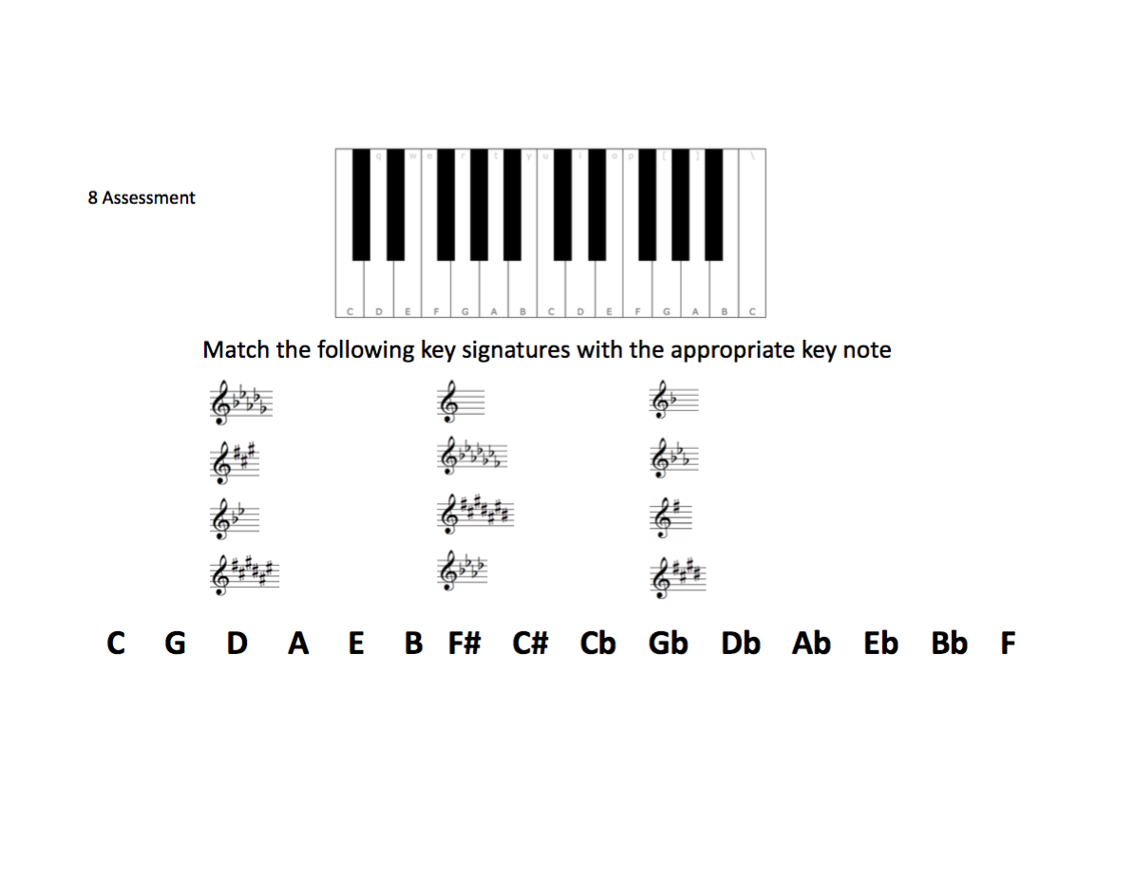
Appendix B
